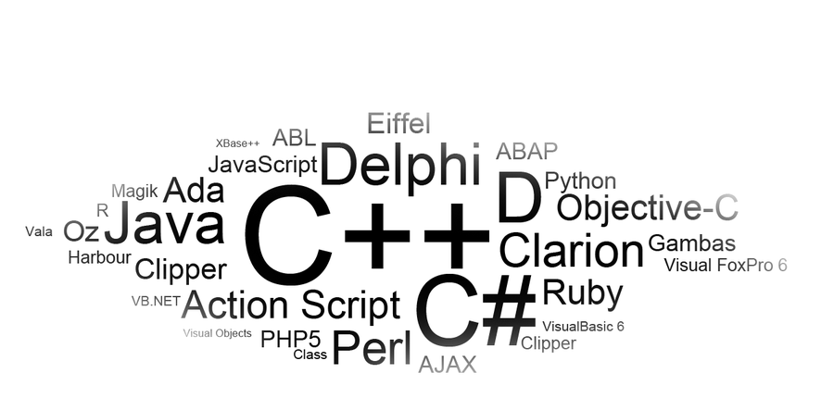




Green Fields Landscaping
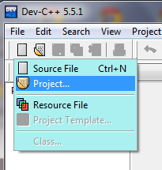
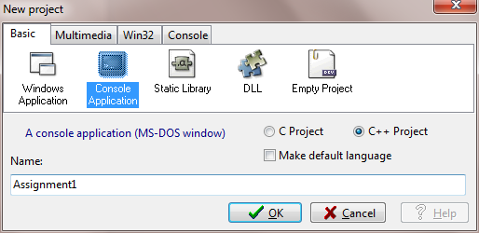
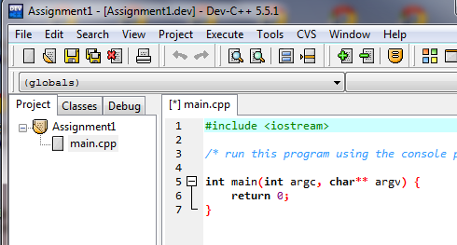

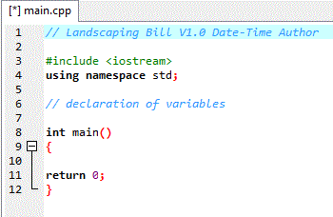

PROBLEM (page 225): Create a program that uses the number of trees, their height, and delivery and planting options to calculate a bill and display an invoice. The price of the trees depends on their height (simplified to be the same for all trees ordered) and a maximum of $100 will be charged for delivery regardless of the number of trees ordered.

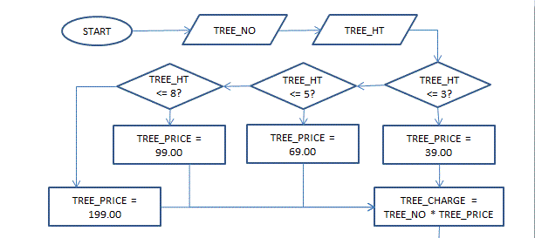
How can you use this statement to determine the variables, where the values for them come from, and develop a flowchart to chart the logic of the program you have been asked to create?

First, look for the relevant nouns and the verbs in the problem description:
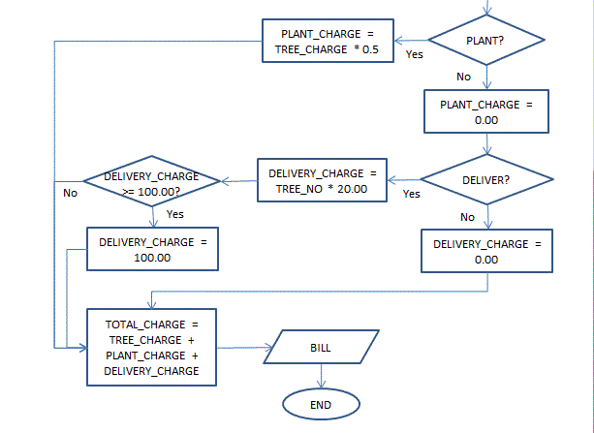
Develop a program that uses the number of trees, their height, and delivery and planting options to calculate a bill and display an invoice. The price of the trees depends on their height (simplified to be the same for all trees ordered) and a maximum of $100 will be charged for delivery regardless of the number of trees ordered.

Nouns: number of trees (TREE_NO – get from customer), height (TREE_HT – get from customer), delivery (DELIVER – ask customer, leads to DELIVERY_CHARGE), planting (PLANT – ask customer, leads to PLANT_CHARGE), price of trees (TREE_PRICE – depends on TREE_HT, leads to TREE_CHARGE).

Verbs: calculate a bill (TOTAL_CHARGE = TREE_CHARGE + PLANT_CHARGE + DELIVERY_CHARGE) and display invoice

The flowchart to the left represents one solution to the problem.
